LESSON 2

FLOW OF COMMUNICATION
Outline:
Flow of Internal Communication
o Formal Internal Communication
o Informal Internal Communication
Direction of Flow within the Organization External Communication
o Various Aspects of Formal External Communication
o Informal External Communication
o Ways of External Communication

An organization is a group of people associated for business, political, professional, religious,
social, or other purposes. Its activities require human beings to interact and react, that is, to
communicate. They exchange information, ideas, plans, and order needed supplies and make
decisions, rules, proposals, contracts, and agreements. All these activities require one skill
that is communication. So we can say that communication is the “Lifeline” of every
organization.
An exchange of information within an organization is called internal communication. It takes place at different levels -- downwards, upwards and horizontal.
To exchange information within and outside the organization, we use a variety of formal and informal forms of communication that carry the flow of information.

Flow of Internal Communication
Internal Communication
Formal
Planned communication
Memo, letter, report, e-mail & faxes that follow
company’s chain of command
Informal

Casual Communication among employees
e-mail face to face conversation
phone calls, discussions

i) Internal Communication
The formal Communication Network
• The formal flow of information follows the official chain of command.
Following is the table to help us understand this official chain of command.
. 7

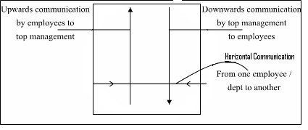President

VP VP VP VP VP
Production Marketing Sales Finance Human
Resources

Sales Sales Sales Sales
Manager Manager Manager Manager
East Midwest West International

District District District
1 2 3
Manager Manager Manager

Sales Sales Sales Sales Sales
Rep Rep Rep Rep Rep

Direction of Flow within the Organization Downward Flow

Organizational decisions are made at top level and then flow down to the people who carry them.
When employees receive appropriate downward communication from the management, they
become motivated and more efficient. They need clear job directions, safety rules, facts about
organizational strategy, products, and viewpoints on important controversial issues. They are also
concerned about their benefits such as health care, promotions, pensions, training, etc.
Upward Flow
To solve problems and make intelligent decision managers need to know that what is going on in the organization. Upward internal communication is also very important. Many executives want comments from employees in addition to the usual periodic reports. Successful managers listen closely to opinions, complaints, problems, and suggestions, especially when these are clearly put forward. They want to know about problem, emerging trends etc.

Horizontal Flow
Horizontal flow takes place between peers in the organizations in order to solve problems,
perform job duties, prepare for meetings, and cooperate on important projects. So, you can
imagine that people spend time on listening to and making requests, writing notes and
memos, and discussing and writing about projects and they do it through communication.
. 8

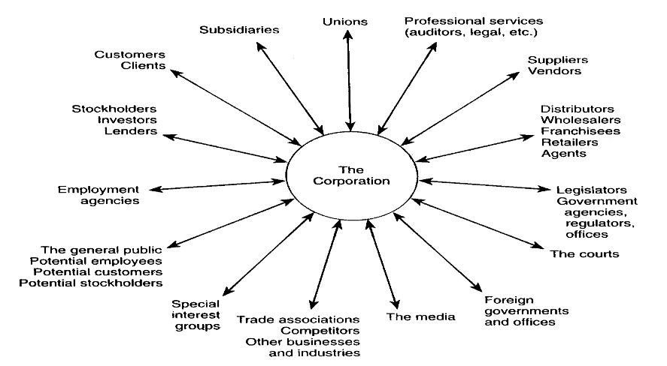Informal Internal Communication
Every organization has an informal communication network - a grapevine - that supplements
official channel. It is an important source of information. It is casual conversation of an
organization.

External Communication
Communication that takes place outside the organization is called external communication. The right letter, proposal, report, telephone call, or personal conversation can win back an angry customer, create a desire for a firm’s product or services, encourage collections, motivate performance, and in general, create goodwill.
Flow of External Communication
External Communication
Formal
Planned communication with outsides
Memo, letter, report
e-mail, Fax’s that follow company’s chain of command
Informal
Casual Communication among Customers,
suppliers, investors, e-mail face to face conversation
phone calls, discussions

Various Aspects of External Communication

Informal External Communication
Although external communication is formal, informal contacts with outsiders are important for
learning customer’s needs. Plenty of high level manager recognize the value of keeping in touch
with “the real world by creating opportunities to talk with and get feedback from customers and
frontline companies.
Ways of External Communication
Letters, pamphlets, annual reports, interviews with the news media etc. Any of these forms can be used to communicate externally. It depends on the needs of the communication.

Effective communication internally and externally can build a good reputation and have a positive impact on the ultimate success of the individual as well as organization.

. 10

